IT University of Copenhagen **Date:** September 28th  
**Course:** Software Engineering **Supervisor:** Renata  
**Group:** 16 **Version:** 3  
**Document nr:** 6 **Tollgate:** 1  
**Responsible:** Cecilie **Status:** Ready for TG1

Portfolio document 6

Project Plan and Estimation

**Students:** **Student ID:** **Email:**  
Carl Villads Dissing Fristam 17950 [cavf@itu.dk](mailto:cavf@itu.dk)Cecilie Malmberg 20963 [cecm@itu.dk](mailto:cecm@itu.dk)Luca Giannini 22150 [lgia@itu.dk](mailto:lgia@itu.dk)Peter Klarskov 19517 [pekd@itu.dk](mailto:pekd@itu.dk)Victoria Hinley Deng 17952 [vide@itu.dk](mailto:vide@itu.dk)

|  |  |  |  |
| --- | --- | --- | --- |
| Version | Change | Author | Date |
| 0 | Added ChangeLog (change me) | Peter | 22.09 |
| 1 | Reviewed + small formatting | Luca | 28.09 |
| 2 | Comments reviewed | Cecilie | 28.09 |
|  |  |  |  |
|  |  |  |  |
|  |  |  |  |

# Project Planning

To keep track of the project we have set up a Trello board. We keep track of all tasks that need to be worked on and what we need to deliver during this course.

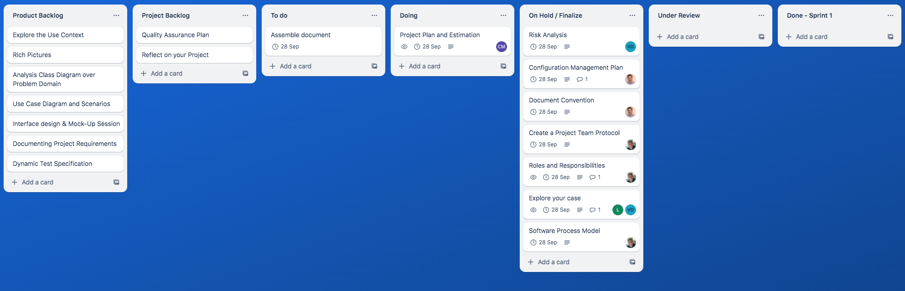

Each task is assigned to either the project or product backlog. Every two weeks we will do a sprint planning and decide which task from the backlogs we are going to work on the next two weeks (Sommerville 2016, 86-87). These tasks will then be moved to the sprint backlog which is called “To do” on our Trello board. During the sprint planning we will also be estimating each task chosen for the sprint. The estimating for each task will be based on the entire workload. Meaning that it will also include activities that prepare the team member to complete the task, such as readings, lectures, and meetings to discuss content with other team members or supervisor meetings. The estimating will also consider how much workload there is in completing and reviewing the task, any changes there might be to it after the review and finally the actual hand in. This is decided by discussing and agreeing within the entire team. The task estimation will be done by giving each task story points, so an easier task might be assigned 2 story points as it will not require must work to finish while a bigger task would be assigned 8.

To agree on how many story points the task should have, every team member says their immediate estimation of the task. In case the difference between story points is significant within the team, we will justify why we gave the task this amount of story points and afterwards find an amount we can all agree on. As we work through the project, we will evaluate our estimations and discuss whether we might have estimated the workload too low or high (Radigan 2023) (Szewczyk 2023)

When the estimation is done, the task is assigned to the team responsible for it. To keep track of what is happening with each task in the sprint, we have divided the board into four categories.

# The four categories in Trello:

The first category is “Doing” and means that the team member, the given task is assigned to, is working on the task.

The second category is “On hold / finalize” which means the team member is either waiting for feedback to finalize the task or that the task is missing small steps such as the right layout or convention.

The third category is “Under review” which means that one or two members of the team is going to pick the task up and review the team members' work responsible.

The fourth category is “Done - #SprintName#,” where we keep track of all the tasks which were reviewed and approved in the current sprint.

# Unfinished tasks

If a task is not finished during the sprint the task will be returned to the backlog and be discussed again during the sprint planning. In this case an evaluation of our estimation of each task can become essential to figure out why the task was not completed on time.